

**Western Australian Certificate of Education**

**ATAR course examination, 2017**

**Question/Answer Booklet**

12 PHYSICS

Name

**Test 2 - Motion and Gravitation**

|  |  |  |  |  |  |  |  |  |  |  |
| --- | --- | --- | --- | --- | --- | --- | --- | --- | --- | --- |
| Student Number: In figures |  |  |  |  |  |  |  |  |  |  |

**Mark: ** In words

#### Time allowed for this paper

Reading time before commencing work: five minutes

Working time for paper: sixty minutes

**Materials required/recommended for this paper**

To be provided by the supervisor

This Question/Answer Booklet

Formulae and Data Booklet

***To be provided by the candidate***

Standard items: pens, (blue/black preferred), pencils (including coloured), sharpener, correction fluid/tape, eraser, ruler, highlighters

Special items: non-programmable calculators satisfying the conditions set by the School Curriculum and Standards Authority for this course

**Important note to candidates**

No other items may be taken into the examination room. It is your responsibility to ensure that you do not have any unauthorised notes or other items of a non-personal nature in the examination room. If you have any unauthorised material with you, hand it to the supervisor before reading any further.

**Structure of this paper**

|  |  |  |  |  |  |
| --- | --- | --- | --- | --- | --- |
| Section | Number of questions available | Number of questions to be answered | Suggested working time  (minutes) | Marks available | Percentage of exam |
| Section One:  Short Answers | 5 | 5 | - | 19 | 50 |
| Section Two:  Problem-solving | 2 | 2 | - | 19 | 50 |
| Section Three:  Comprehension | - | - | - | - | - |
|  |  |  |  | **Total** | 100 |

**Instructions to candidates**

1. The rules for the conduct of examinations at Holy Cross College are detailed in the College Examination Policy*.* Sitting this examination implies that you agree to abide by these rules.

2. Write your answers in this Question/Answer Booklet.

3. Working or reasoning should be clearly shown when calculating or estimating answers.

4. You must be careful to confine your responses to the specific questions asked and to follow any instructions that are specific to a particular question.

5. Spare pages are included at the end of this booklet. They can be used for planning your

responses and/or as additional space if required to continue an answer.

• Planning: If you use the spare pages for planning, indicate this clearly at the top of the page.

• Continuing an answer: If you need to use the space to continue an answer, indicate in the original answer space where the answer is continued, i.e. give the page number. Fill in the number of the question(s) that you are continuing to answer at the top of the page.

6. Answers to questions involving calculations should be ***evaluated and given in decimal***

***form*.** It is suggested that you quote all answers to ***three significant figures***, with the

exception of questions for which estimates are required. Despite an incorrect final result, credit may be obtained for method and working, providing these are ***clearly and legibly set out***.

7. Questions containing the instruction "estimate" may give insufficient numerical data for their solution. Students should provide appropriate figures to enable an approximate solution to be obtained. Give final answers to a maximum of two significant figures and include appropriate units where applicable.

8. Note that when an answer is a vector quantity, it must be given with magnitude and direction.

9. In all calculations, units must be consistent throughout your working.

1. A mass of 0.500 kg is whirled in a horizontal circle at one end of a string 60.0 cm long. If the string can just support a mass of 15.0 kg without breaking, calculate the smallest period of revolution (which corresponds to the fastest orbital speed) the mass can achieve. (Assume the mass remains perfectly horizontal.) **(4 marks)**

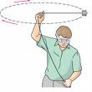

2. Astrophysicists studying a small moon orbiting Jupiter noted that its period of revolution was 11.4 Earth days and that its path was circular with a diameter of 5.10 x 106 km. Using this information, what would the scientists have calculated as Jupiter's mass?

**(4 marks)**

3. A pilot of mass 80.0 kg performs a perfect "loop-the-loop" manoeuvre in a small stunt plane. Given that the plane maintains a constant speed of 1.20 x 102 kmh-1 in a vertical circle of diameter 1.80 x 102 m, calculate the reaction force exerted by the seat onto the pilot as he goes through the top of the loop upside down. **(4 marks)**

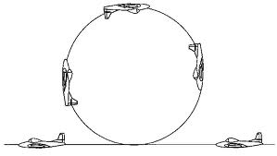

4. Use Physics principles and the diagrams below to explain why curves on open highways (where cars travel at high speeds) are built with a bank (or slope) to enable a car to safely make the turn. You must explain the Physics involved in ***both situations*** shown in the diagrams. **(4 marks)**

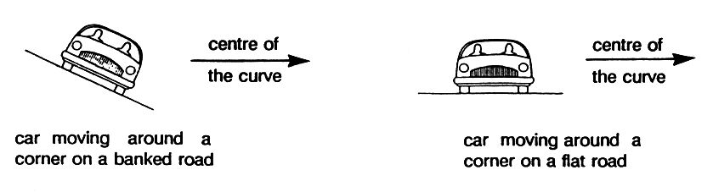

5. A child swings through an arc of 40.0° on a playground swing. Use Physics principles to explain why she "feels heaviest" when passing through the bottom of the arc.

**(3 marks)**

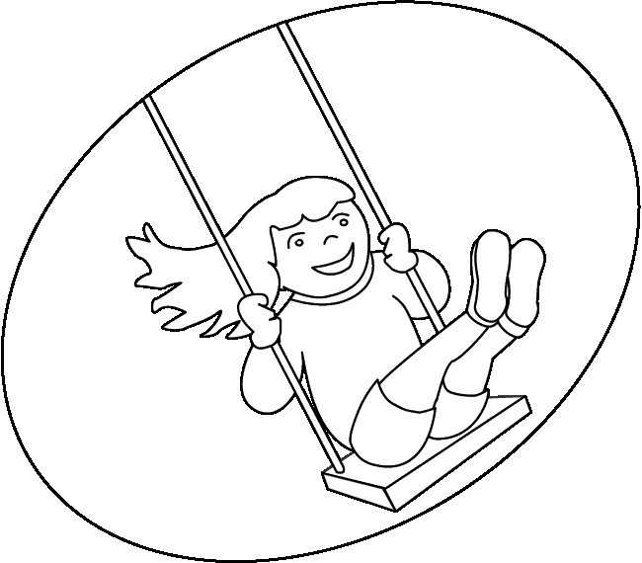

6. Suppose that NASA has decided to put a satellite in orbit around the Moon.

(a) Show in a diagram the direction of the force exerted on the satellite by the Moon.

**(1 mark)**

(b) What is the acceleration due to the Moon's gravity at a height of 2.50 x 103 km above the surface of the Moon? **(4 marks)**

(c) If the satellite is to have an orbital period of 24.0 hours, find the height of the orbit above the Moon's surface. **(4 marks)**

7. A ride in Sideshow Alley at the Royal Show is the chair merry- go-round . Riders are whirled in a circle whilst sitting in a chair attached by ***two chains*** to the rotating frame.

At a particular instant during the ride , a 60.0 kg rider is orbiting 3.80 m from the central support (as shown in the diagram). The chains supporting the chair form an angle of 25.0° to the vertical.

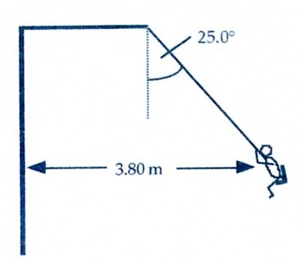

(a) Calculate the tension exerted in each chain at this instant. Assume the horizontal bar does not exert a horizontal force. **(4 marks)**

(b) What is the period of orbit of the rider? **(4 marks)**

(c) Explain how the rider remains in the chair whilst orbiting. **(2 marks)**